**Lab Assignment 3**

**Dataset Given**

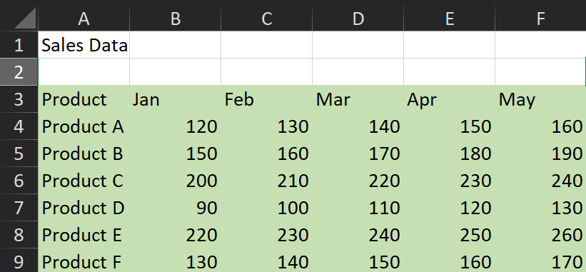

**Q1. Use HLOOKUP to find the sales for Product A in March.**

**Ans.** Formula Used: =HLOOKUP("Mar",A3:F9,2,FALSE)

Output Obtained: Sales of Product A in March = 140

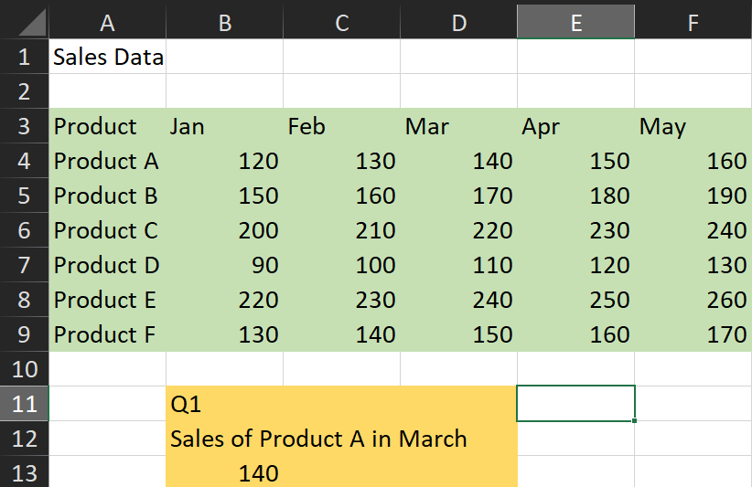

**Q2. Use HLOOKUP to find the sales for Product D in May.**

**Ans.** Formula Used: =HLOOKUP("May",A3:F9,5,FALSE)

Output Obtained: Sales of Product D in May = 130

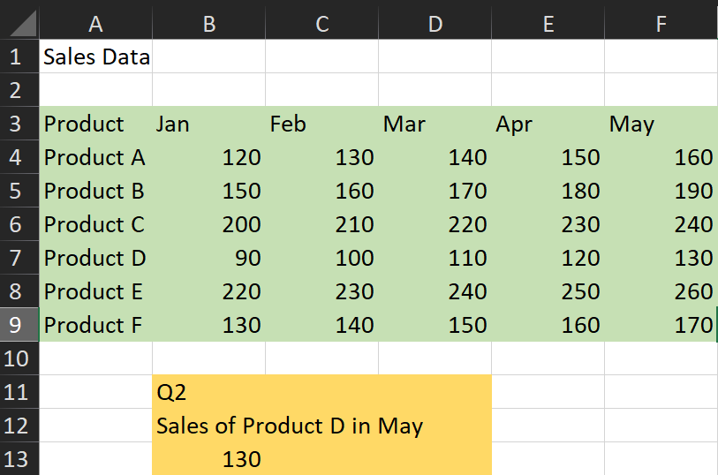

**Q3. Use HLOOKUP to find the sales for Product C in February.**

**Ans.** Formula Used: =HLOOKUP("Feb",A3:F9,4)

Output Obtained: Sales of Product C in February = 210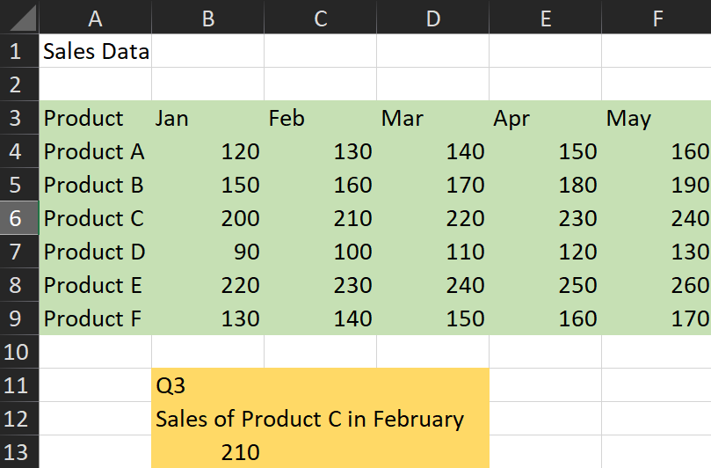

**Q4. Use HLOOKUP to find the sales for each month for a product, then calculate the total sales for that product.**

**Ans.** Here, we will be calculating the total sales made for each Product

Formula Used:

* Product A: =SUM(HLOOKUP("Jan",A3:F9,2,FALSE),HLOOKUP("Feb",A3:F9,2,FALSE),HLOOKUP("Mar",A3:F9,2,FALSE),HLOOKUP("Apr",A3:F9,2,FALSE),HLOOKUP("May",A3:F9,2,FALSE))
* Product B: =SUM(HLOOKUP("Jan",A3:F9,3,FALSE),HLOOKUP("Feb",A3:F9,3,FALSE),HLOOKUP("Mar",A3:F9,3,FALSE),HLOOKUP("Apr",A3:F9,3,FALSE),HLOOKUP("May",A3:F9,3,FALSE))
* Product C: =SUM(HLOOKUP("Jan",A3:F9,4,FALSE),HLOOKUP("Feb",A3:F9,4,FALSE),HLOOKUP("Mar",A3:F9,4,FALSE),HLOOKUP("Apr",A3:F9,4,FALSE),HLOOKUP("May",A3:F9,4,FALSE))
* Product D: =SUM(HLOOKUP("Jan",A3:F9,5,FALSE),HLOOKUP("Feb",A3:F9,5,FALSE),HLOOKUP("Mar",A3:F9,5,FALSE),HLOOKUP("Apr",A3:F9,5,FALSE),HLOOKUP("May",A3:F9,5,FALSE))
* Product E: =SUM(HLOOKUP("Jan",A3:F9,6,FALSE),HLOOKUP("Feb",A3:F9,6,FALSE),HLOOKUP("Mar",A3:F9,6,FALSE),HLOOKUP("Apr",A3:F9,6,FALSE),HLOOKUP("May",A3:F9,6,FALSE))
* Product F: =SUM(HLOOKUP("Jan",A3:F9,7,FALSE),HLOOKUP("Feb",A3:F9,7,FALSE),HLOOKUP("Mar",A3:F9,7,FALSE),HLOOKUP("Apr",A3:F9,7,FALSE),HLOOKUP("May",A3:F9,7,FALSE))

Output Obtained:

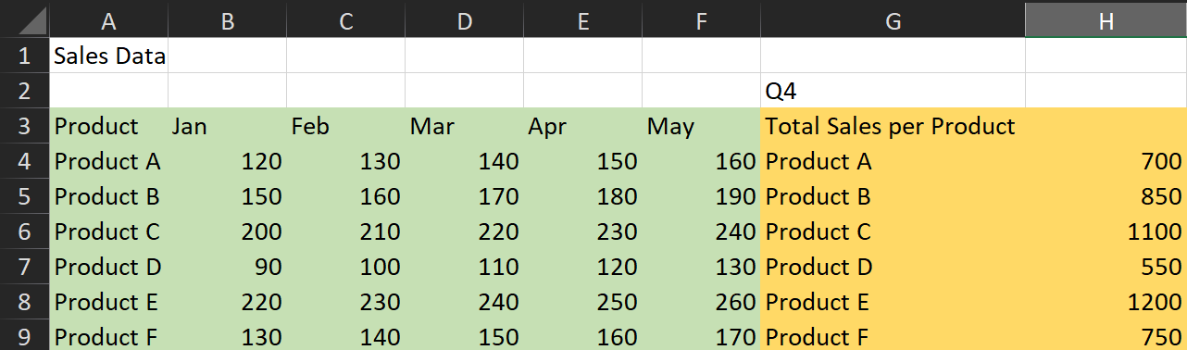

**Q5. Use HLOOKUP to find the maximum sales value for Product B across all months.**

**Ans.** Formula Used: =MAX(HLOOKUP("Jan",A3:F9,3,FALSE),HLOOKUP("Feb",A3:F9,3,FALSE),HLOOKUP("Mar",A3:F9,3,FALSE),HLOOKUP("Apr",A3:F9,3,FALSE),HLOOKUP("May",A3:F9,3,FALSE))

Output Obtained: Max sales for Product B across all months = 190

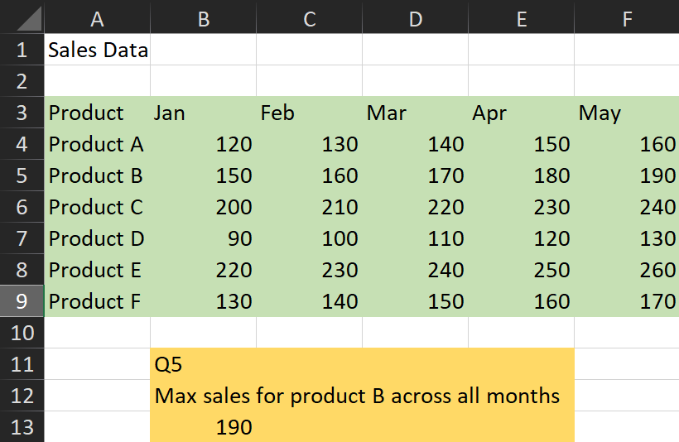

**Q6. Use HLOOKUP to find the minimum sales value for Product F across all months.**

**Ans.** Formula Used: =MIN(HLOOKUP("Jan",A3:F9,7,FALSE),HLOOKUP("Feb",A3:F9,7,FALSE),HLOOKUP("Mar",A3:F9,7,FALSE),HLOOKUP("Apr",A3:F9,7,FALSE),HLOOKUP("May",A3:F9,7,FALSE))

Output Obtained: Min sales for Product F across all months = 130

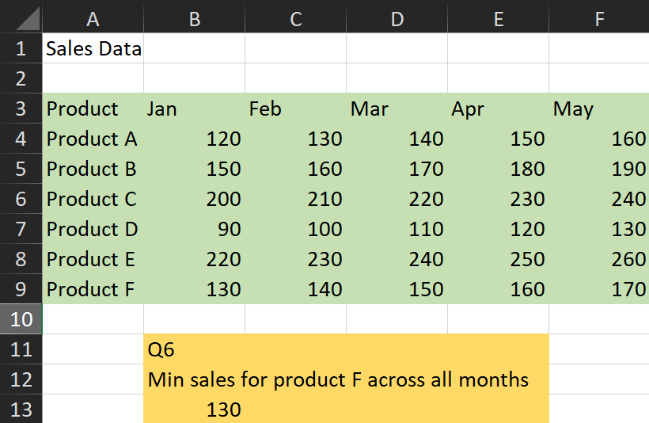

**Q7. Use HLOOKUP to find the average sales value for Product E across all months.**

**Ans.** Formula Used: =AVERAGE(HLOOKUP("Jan",A3:F9,6,FALSE),HLOOKUP("Feb",A3:F9,6,FALSE),HLOOKUP("Mar",A3:F9,6,FALSE),HLOOKUP("Apr",A3:F9,6,FALSE),HLOOKUP("May",A3:F9,6,FALSE))

Output Obtained: Average Sales for Product E across all months = 240

